Data Types in ES6 and forth

- Boolean (boolean – true, false)
- Number (number)
- String (string)
- Null (null)
- Undefined (undefined)
- Symbol (symbol) - in ES 6
- BigInt( bigint – n) – ES2020 - in ES11

first five are data types in ES5
These all are premitive data types

- Function (function)
- Object (object)
These two are structural data types.

Symbol
Create variable
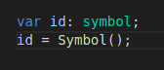

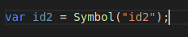

this is used to introduce private properties to java script objects
private properties mean – the person that symbol is created only can access to that
Unique identifier is generated from this symbol.
No need to write “id2” part. It’s just for debugging purpose to identify variables.
Usage of symbol: -
to create hidden properties (like private variables in java) in objects
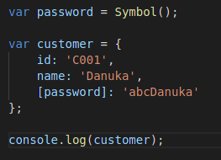
symbol literal:-

Others can use only id and name in this format.They cannot see the password.
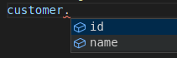

Change and read symbol values
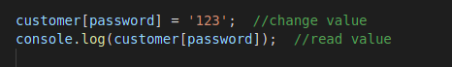

when print all the attributes of an object using loop → symbol value is not print
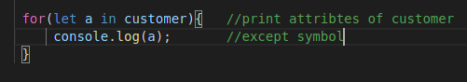

define variable in global context, and use it in another script or a module
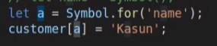

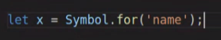

continue on 1:52…..

